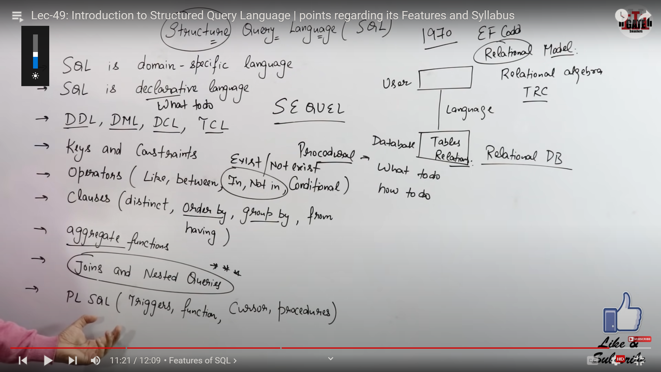

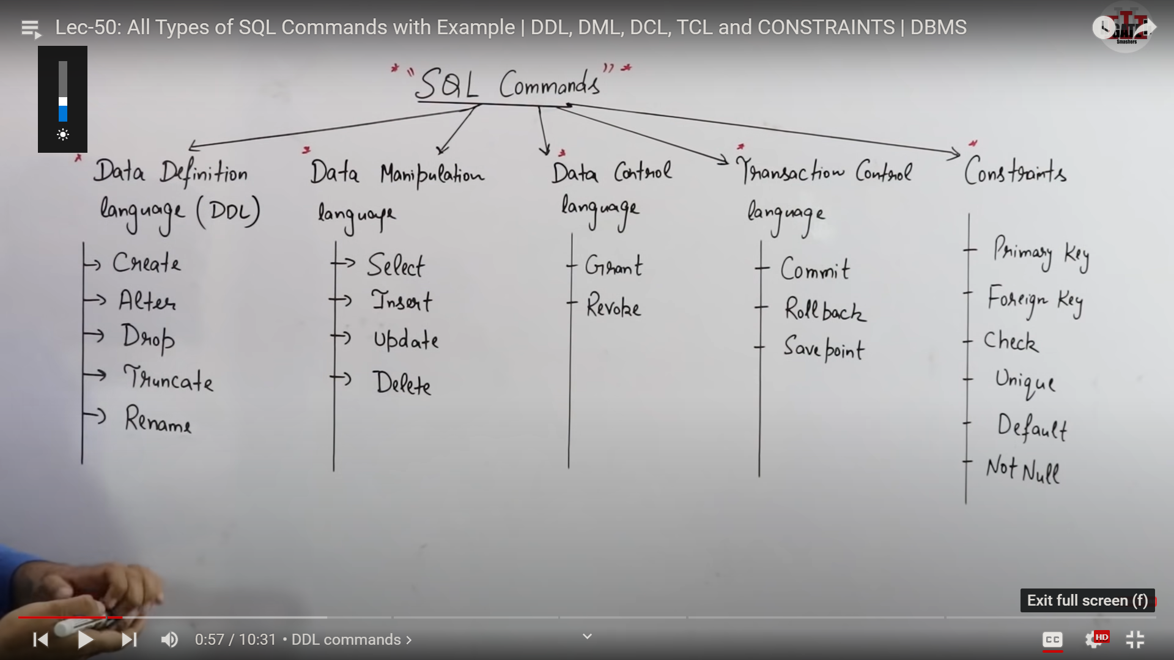

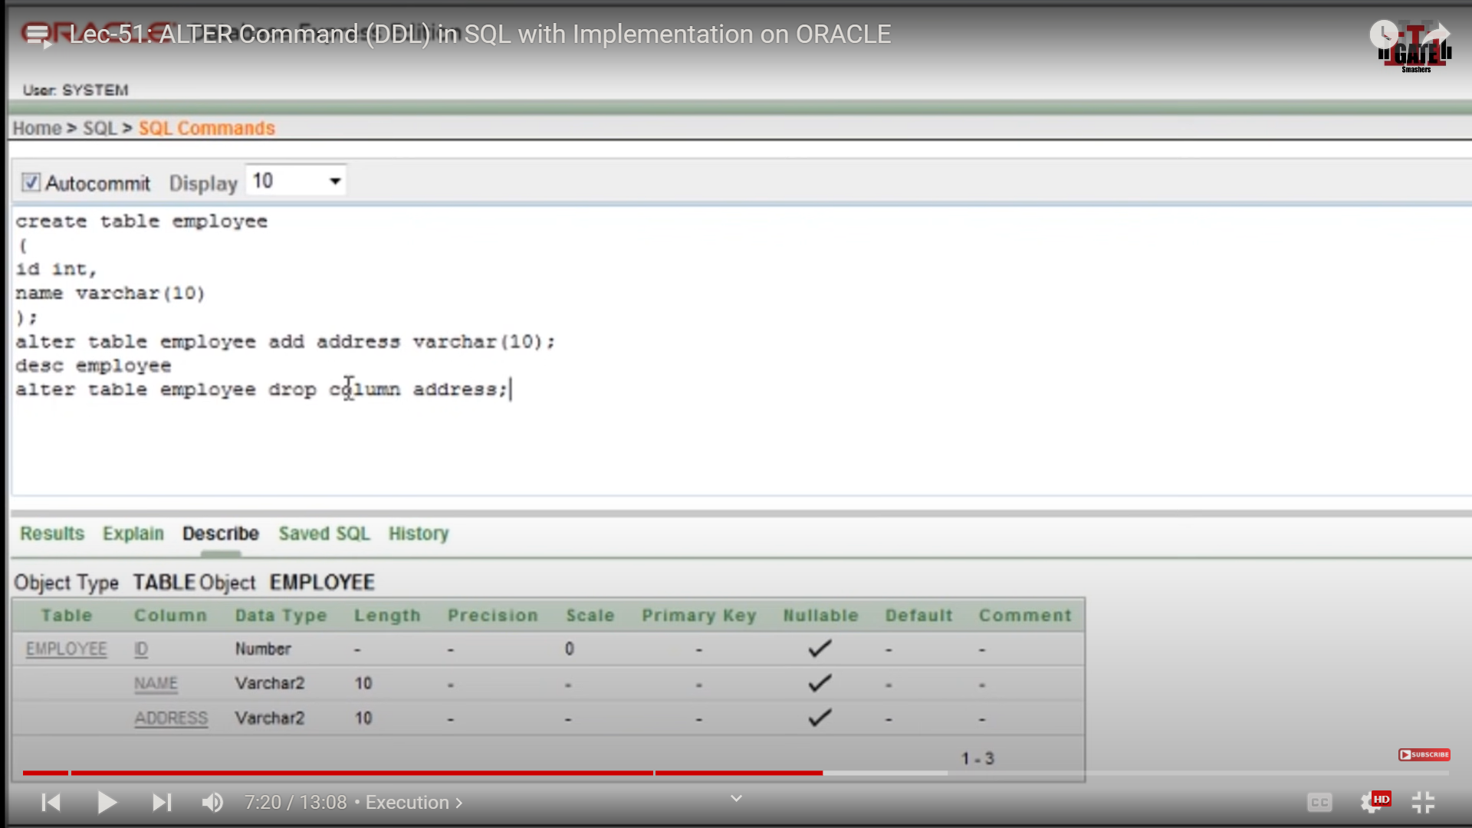

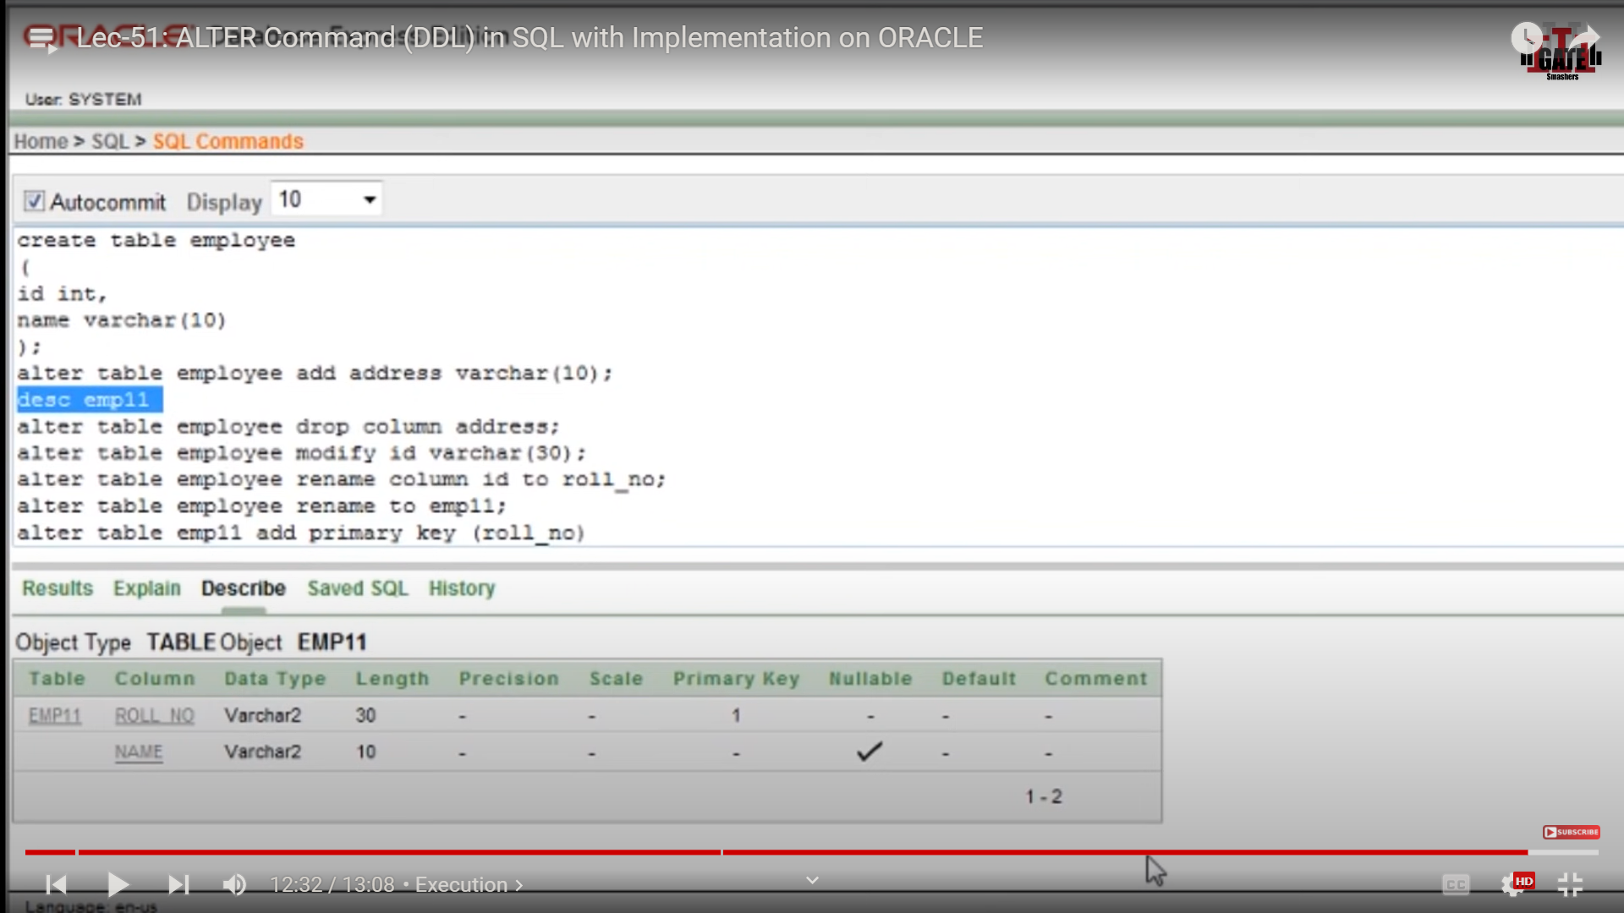

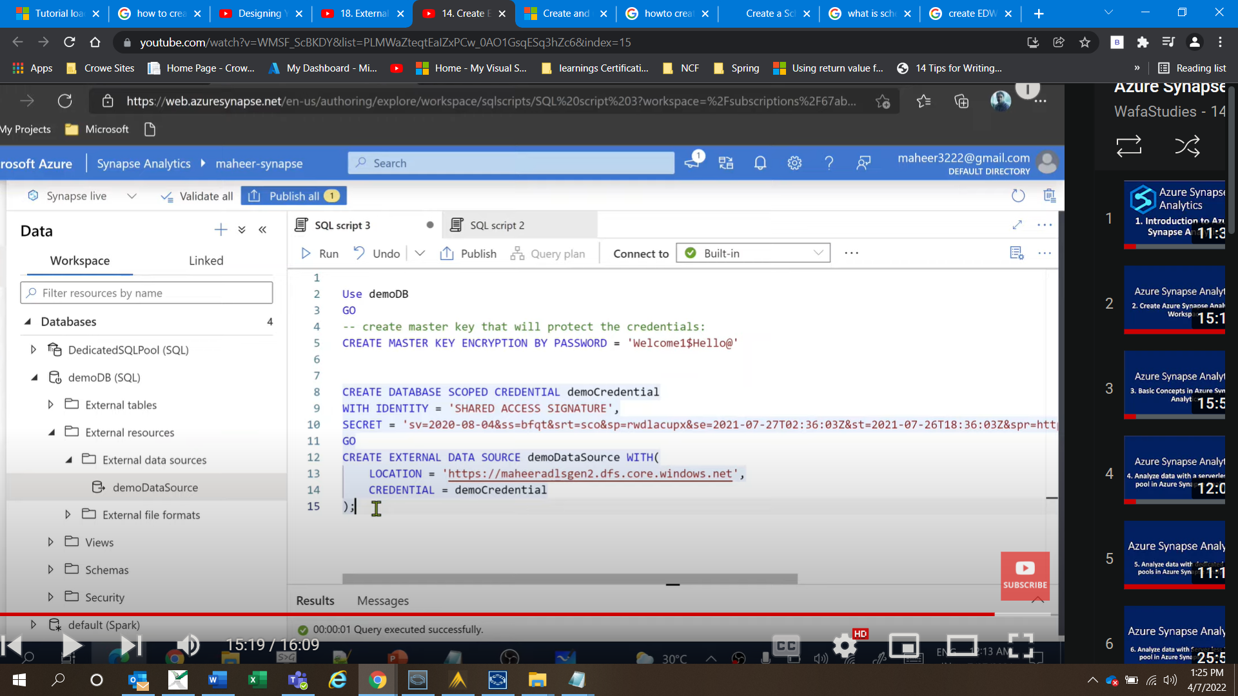

File format

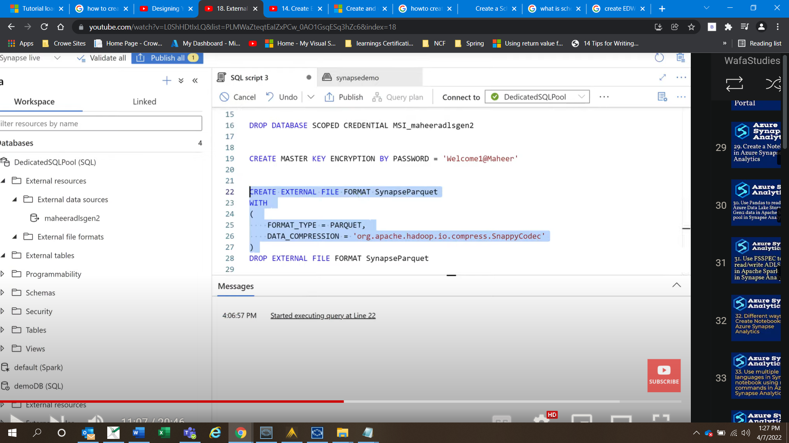

Create external table

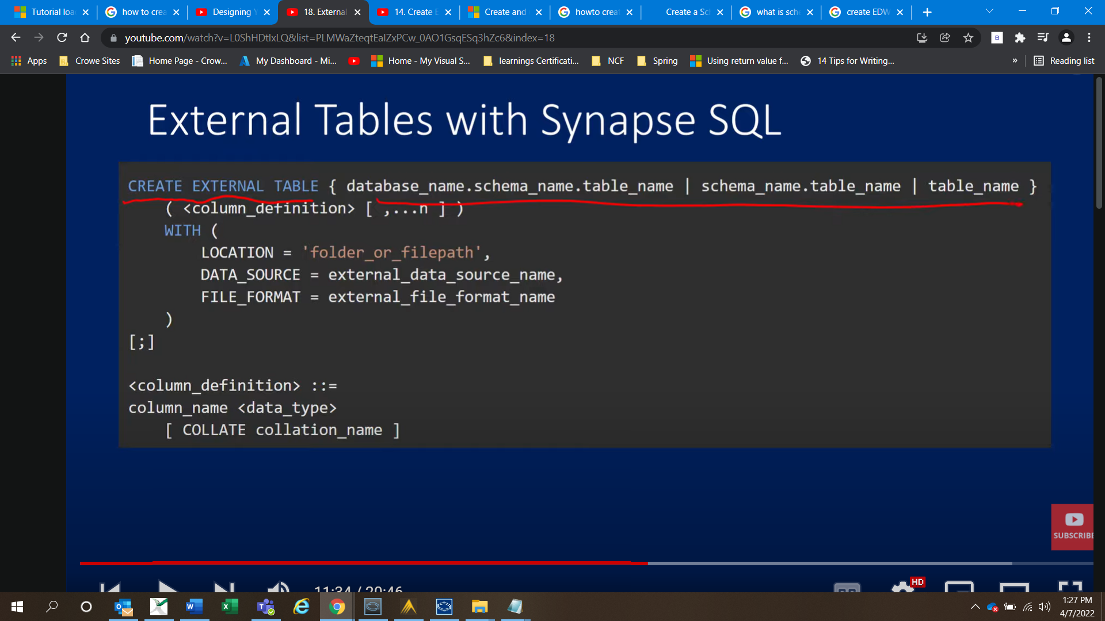

**External tables in dedicated SQL pool and serverless SQL pool**

You can use external tables to:

* Query Azure Blob Storage and Azure Data Lake Gen2 with Transact-SQL statements.
* Store query results to files in Azure Blob Storage or Azure Data Lake Storage using [CETAS](https://docs.microsoft.com/en-us/azure/synapse-analytics/sql/develop-tables-cetas).
* Import data from Azure Blob Storage and Azure Data Lake Storage and store it in a dedicated SQL pool (only Hadoop tables in dedicated pool).

You can create external tables in Synapse SQL pools via the following steps:

1. [CREATE EXTERNAL DATA SOURCE](https://docs.microsoft.com/en-us/azure/synapse-analytics/sql/develop-tables-external-tables?tabs=hadoop#create-external-data-source) to reference an external Azure storage and specify the credential that should be used to access the storage.
2. [CREATE EXTERNAL FILE FORMAT](https://docs.microsoft.com/en-us/azure/synapse-analytics/sql/develop-tables-external-tables?tabs=hadoop#create-external-file-format) to describe format of CSV or Parquet files.
3. [CREATE EXTERNAL TABLE](https://docs.microsoft.com/en-us/azure/synapse-analytics/sql/develop-tables-external-tables?tabs=hadoop#create-external-table) on top of the files placed on the data source with the same file format.